Understanding Fractions as Numbers

INSTRUCTIONAL ACTIVITY SUPPLEMENT

Lesson 1









Fraction Models







Fraction Representations

|  |  |  |  |  |  |  |
| --- | --- | --- | --- | --- | --- | --- |
|  | Drawing of one whole | Drawing of a proper fraction | Word name of the proper fraction | Symbolic name of the fraction | Drawing of an improper fraction | Symbolic name of the improper fraction |
| Set Model |  |  |  |  |  |  |
| Length Model |  |  |  |  |  |  |
| Area Model |  |  |  |  |  |  |

Understanding Fractions as Numbers

Lesson 2

Use the following models to answer the questions.

1.

 Unit (equal-size parts):

_________________________

Shade the unit fraction blue.

How many copies of the unit fraction make one whole?

_________________________

2.

 Circle each copy of the unit fraction.

Unit (equal-size groups):

_________________________

How many copies of the unit fraction make one whole?

_________________________

3.

Finish dividing the pentagon into equal-size parts.

Unit (equal-size parts):

_________________________

How many copies of the unit fraction make one whole?

_________________________

4.



Unit (equal-size lengths): _________________________

How many unit fractions are represented by the green arrow?

_________________________

How many copies of the unit fraction make up the whole?

_________________________

5.



Iterate the line segment to find the number of equal-size lengths.

Unit (equal-size lengths): _________________________

Draw an orange arrow to represent one unit fraction.

How many copies of the unit fraction make up the whole?

_________________________

6.

Units (equal-size groups): _________________________

Shade the unit fraction purple.

How many copies of the unit fraction make up the whole?

_________________________

7. Represent five-eighths on the number line.



8. If the rectangle on the left displays one whole, use the rectangle on the right to represent eight-tenths.



9. Use the set of shapes to answer the following questions.

9.a. How many shapes make up the whole set?

9.b. What fraction of the whole set of shapes are circles?

9.c. Redraw the set of shapes divided into thirds. How many shapes are in one-third?

10. Circle the models that are shaded to represent three-fifths.



a. b.



c. d.



e.

Understanding Fractions as Numbers

INSTRUCTIONAL ACTIVITY SUPPLEMENT

Lesson 2

If the wholes are the same size,

and the equal-size parts are **smaller**,

then the *number* of equal-size parts is ______________________________.

If the wholes are the same size,

and the equal-size parts are **larger**,

then the *number* of equal-size parts is ______________________________.













Understanding Fractions as Numbers

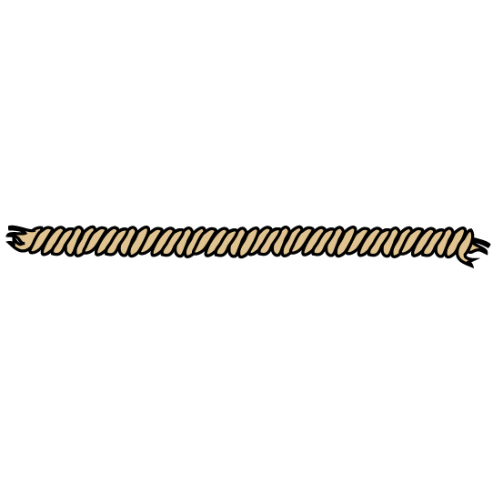Lesson 3

1. Use your piece of string to complete the following.

* Use the color **red** to mark the string at the length of one-half of the whole rope.
* Use the color **blue** to mark the string at the lengths of one-third and two-thirds of the whole rope.
* Use the color **green** to mark the string at the lengths of one-fourth, two-fourths, and three-fourths.
* Compare your marks with the *Answer Number Line*.

1.a. Which fraction of the string was the easiest to identify? Why?

1.b. Which fraction of the string was the most difficult to identify? Why?

1.c. Were any of your marks incorrect? If so, which one(s)? Explain how you identified them and what you would do differently next time.

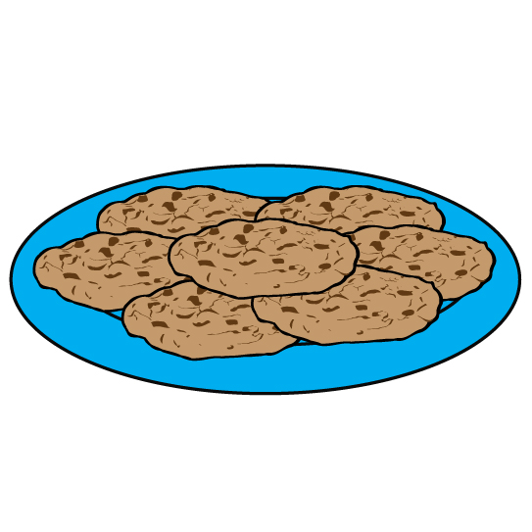2. Jackson is sharing cookies and milk with four of his friends. There is enough milk to fill one full glass. If Jackson divides the milk equally, what fraction of the full glass of milk will Jackson and each of his friends get?

2.a. Draw a model to represent the milk *before* and *after* it was shared.

Before:

After

2.b. What fraction of the one full glass does each person get? How do you know?

2.c. Write another problem situation like Jackson’s, where one whole is divided into five equal-size parts.

**3. Answer the questions using the book *Give Me Half!*

3.a. What does it mean when the parent says the pizza must be cut the same for the brother and sister?

**3.b. Why does the pizza need to be cut the same for the brother and sister?

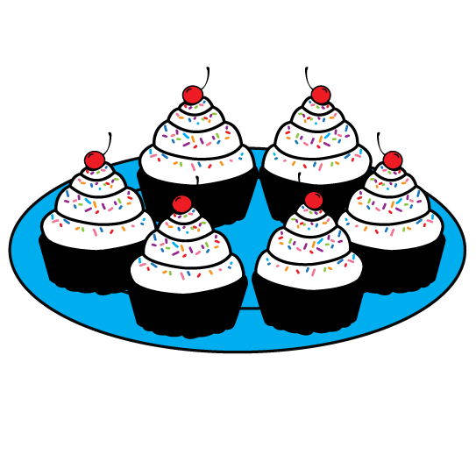3.c. When the brother and sister share the cupcakes, what represents one whole? How do you know?

**3.d. How are the whole for the pizza and the whole for the cupcakes different? How are they the same?



3.e. What type of fraction model would best represent the pizza? Why?

3.f. What type of fraction model would best represent the cupcakes? Why?

3.g. If the brother has three cookies and he shares them equally with the sister, draw how many cookies each child will get. Explain what you did and how you know your answer is correct.

3.h. Describe how the author represented the fractions.

4. Use the number line to answer the following questions.



4.a. What represents the whole?

4.b. How many equal-size parts has the whole been divided into?

4.c. How many equal-size parts have been identified?

4.d. Use the word form and symbolic form to name the fraction that is represented on the number line.

5. Match the fraction model with the correct fraction name. For the area models, consider the fraction that is represented by the shaded parts.



a. eight-sixths



b. $\frac{2}{5}$



c. $\frac{4}{8}$



d. three-ninths



e.

6. Draw a fraction model of your choice to represent the fraction that is described.

* The whole is divided into eight equal-size parts.
* Identify five copies of the unit fraction.
* The symbolic representation of the fraction is $\frac{5}{8}$.

Model:

Understanding Fractions as Numbers

Lesson 4

1. Use the model to complete the blanks. One whole is the length between 0 and 1. Write all fractions symbolically.



a. Unit (equal-size parts): ___________________________

b. Unit fraction: ___________________________________

c. Number of copies of unit fraction identified: ­­­­­­­­___________

d. Fraction represented by the ray: ____________________

2. Use the model to complete the blanks. One hexagon (six-sided shape) represents one whole. Write all fractions symbolically.



a. Unit (equal-size parts): ___________________________

b. Unit fraction: ___________________________________

c. Number of copies of unit fraction shaded: _____________

d. Fraction represented by the shaded parts: ____________

3. Use the model to complete the blanks. One whole is a set of three large circles with three small circles each. Write all fractions symbolically.



a. Unit (equal-size set): ___________________________

b. Unit fraction: ___________________________________

c. Number of copies of unit fraction shaded: _____________

d. Fraction represented by the shaded sets: ____________

Understanding Fractions as Numbers

INSTRUCTIONAL ACTIVITY SUPPLEMENT

Lesson 4

|  |  |  |
| --- | --- | --- |
| three-fifths | ten-eighths | six-sixths |
|  |  | one shape is one whole |
| $$\frac{3}{9}$$ | $$\frac{9}{3}$$ | $$\frac{8}{7}$$ |
| six-wholes | three-halves | fifteen-fifths |
|  | one shape is one whole | one set is one whole |
| $$\frac{10}{10}$$ | $$\frac{2}{12}$$ | $$\frac{5}{1}$$ |

Greater Than, Less Than, or Equal to One

|  |  |  |  |
| --- | --- | --- | --- |
| greater Than one | Less than one | equal to one | not sure |
|  |  |  |  |

Understanding Fractions as Numbers

Lessons 1 –4

1. Draw one whole for each situation using the given representation. Write what the whole represents. *Example: The rectangle is one whole candy bar.*
   1. Sam is baking a cherry pie to share at a school party. Draw the pie as an area model.
   2. Bella has a bag of 12 circle erasers in different colors. Draw the bag of erasers as a set model.
   3. Adam is describing the distance he travels to school. Draw a length model that displays one whole unit.

1. Circle the model that represents the given fraction. Explain why you chose the model you circled. Each length between 0 and 1 is one whole, each single shape is one whole, and each set is one whole.
   1. One-half





I chose this model because:

* 1. Two-eighths



 

I chose this model because:







$\frac{7}{10}$

I chose this model because:

1. Draw a model to show the fraction described, then write the fraction symbolically.
   1. Alex has a bag with four cookies. Alex and his sister share the cookies so they both get an equal amount. Create a model to show what fraction of the bag of cookies Alex gets.

Alex will get _____________ of the bag of cookies.

* 1. Bryson has one foot of string. He needs 6 copies of $\frac{1}{9}$ of one foot of string for an art project. Create a model to show what fraction of the foot of string Bryson will need. One whole is equal to one foot.

Bryson will need _____________ of one foot of string.

* 1. Sam and Terri are sharing a piece of paper. If they divide the paper into 8 equal-size parts and they each take 3 parts, what fraction of the whole piece of paper will be left over?

_____________ of the whole piece of paper will be left over.

1. What is a unit fraction?
   1. Use the model to show the unit fraction, then write the unit fraction symbolically.

The unit fraction for this set model is _____________.



* 1. Use the model to show the unit fraction, then write the unit fraction symbolically.

The unit fraction for this length model is ___________.



* 1. Use the model to show the unit fraction, then write the unit fraction symbolically.

The unit fraction for this area model is ____________.



1. Circle the unit fraction that has larger equal-size parts in the same whole. Support your answer with words or models.
   1. or

* 1. or

1. Identify or represent the given fraction, then circle an answer to indicate whether the fraction is greater than, less than, or equal to one whole. Write all fractions symbolically.
   1. Show the fraction $\frac{6}{4}$ on the number line. The distance from 0 to 1 is one whole.



$\frac{6}{4}$ is (greater than / less than / equal to) one whole.

* 1. Show the fraction eight-eighths on the area model. One circle is equal to one whole.

  
 is (greater than / less than / equal to) one whole.

* 1. One large rectangle is one whole. What is the fraction shown by the shaded parts?

 The fraction shown by the shaded parts is:

is (greater than / less than / equal to) one whole.